Containerization & Kubernetes
Deployment Challenge
Assignment 2 • Cloud & Network Deployment (MDM) • Final Year

Student Name | Sagar
Institution | MIT Academy of Engineering, Pune
Submission Date | 23 October 2026
Subject | Cloud & Network Deployment (MDM) — Final Year

1. Introduction & Objective

This assignment demonstrates containerizing a static web application using Docker and deploying it on a Kubernetes cluster using Minikube. The project covers all aspects of cloud-native deployment including Dockerfile creation, image building, Kubernetes Deployment and Service configuration, health probes, resource management, and live demonstration.

Tools & Versions Used
Tool | Version | Purpose
Docker | 28.4.0 | Container runtime — build & run images
kubectl | v1.34.1 | Kubernetes CLI — apply manifests, inspect resources
Minikube | v1.37.0 | Local single-node Kubernetes cluster

2. Application Overview

A static HTML web page served by Nginx (Alpine-based) was selected as the application. The page displays assignment metadata, technology stack, and a live status indicator. It uses modern CSS (glassmorphism, gradients, animations) and loads from Google Fonts.

Project File Structure
Assignment 2/
├── index.html ← Web application (Nginx static site)
├── nginx.conf ← Custom Nginx config (gzip, caching, security headers)
├── Dockerfile ← Optimized Docker image definition
├── deploy.ps1 ← One-click automated deployment script
├── README.md ← Full documentation
└── k8s/
├── deployment.yaml ← Kubernetes Deployment (3 replicas, probes, limits)
└── service.yaml ← Kubernetes NodePort Service (port 30080)

3. Dockerfile & Image Creation

The Dockerfile uses the official nginx:1.25-alpine base image (minimal ~23 MB), adds OCI metadata labels, copies the application files, and configures a HEALTHCHECK so Kubernetes probes can verify container readiness. Nginx runs in foreground (daemon off) as required for containers.
# ── Dockerfile ──────────────────────────────────────────
FROM nginx:1.25-alpine
LABEL maintainer="Sagar"
LABEL description="Containerized Nginx web app for K8s assignment"
LABEL version="1.0"
# Remove default Nginx static assets
RUN rm -rf /usr/share/nginx/html/*
# Copy application files
COPY index.html /usr/share/nginx/html/index.html
COPY nginx.conf /etc/nginx/conf.d/default.conf
EXPOSE 80
# Health check — Kubernetes readiness probes rely on this
HEALTHCHECK --interval=30s --timeout=5s --start-period=5s --retries=3 \
CMD wget --quiet --tries=1 --spider http://localhost:80/ || exit 1
CMD ["nginx", "-g", "daemon off;"]

3.1 Build Output (Evidence)
Command executed:
# Point Docker CLI to Minikube's internal daemon
& minikube -p minikube docker-env --shell powershell | Invoke-Expression
# Build image
docker build -t nginx-assignment:1.0 .
Build output (key steps):
#1 [internal] load build definition from Dockerfile DONE 0.1s
#2 [internal] load metadata for nginx:1.25-alpine DONE 3.7s
#4 FROM docker.io/library/nginx:1.25-alpine DONE 20.6s
#6 [2/4] RUN rm -rf /usr/share/nginx/html/* DONE 1.8s
#7 [3/4] COPY index.html /usr/share/nginx/html/index.html DONE 0.1s
#8 [4/4] COPY nginx.conf /etc/nginx/conf.d/default.conf DONE 0.0s
#9 exporting to image
#9 writing image sha256:a6881a4bcd64... done
#9 naming to docker.io/library/nginx-assignment:1.0 done ✓
Image verification:
REPOSITORY TAG IMAGE ID CREATED SIZE
nginx-assignment 1.0 a6881a4bcd64 About a minute ago 48.3MB

4. Container Execution

The container was first tested locally before Kubernetes deployment to confirm the application serves correctly inside Docker.
# Run container locally for testing
docker run -d -p 8080:80 --name nginx-test nginx-assignment:1.0
# Verify running
docker ps
# CONTAINER ID IMAGE COMMAND STATUS
# 7f3a1e... nginx-assignment:1.0 "nginx -g 'daemon of…" Up
# Access at: http://localhost:8080 ← Application served correctly
# Clean up
docker stop nginx-test && docker rm nginx-test
Kubernetes also ran health probes against each pod confirming HTTP 200 responses — visible in the pod logs shown in Section 6.

5. Kubernetes Deployment Configuration

The Deployment manifest defines 3 replicas with a RollingUpdate strategy (zero-downtime), CPU/memory resource requests and limits, liveness probes, and readiness probes.
# k8s/deployment.yaml
apiVersion: apps/v1
kind: Deployment
metadata:
name: nginx-assignment-deployment
labels:
app: nginx-assignment
version: "1.0"
tier: frontend
spec:
replicas: 3
selector:
matchLabels:
app: nginx-assignment
strategy:
type: RollingUpdate
rollingUpdate:
maxSurge: 1
maxUnavailable: 0 # Zero-downtime rolling updates
template:
metadata:
labels:
app: nginx-assignment
spec:
containers:
- name: nginx-app
image: nginx-assignment:1.0
imagePullPolicy: Never
ports:
- containerPort: 80
resources:
requests:
memory: "64Mi"
cpu: "50m"
limits:
memory: "128Mi"
cpu: "200m"
livenessProbe:
httpGet:
path: /
port: 80
initialDelaySeconds: 10
periodSeconds: 15
readinessProbe:
httpGet:
path: /
port: 80
initialDelaySeconds: 5
periodSeconds: 10

5.1 Kubernetes Service Configuration
# k8s/service.yaml
apiVersion: v1
kind: Service
metadata:
name: nginx-assignment-service
spec:
type: NodePort
selector:
app: nginx-assignment
ports:
- name: http
protocol: TCP
port: 80
targetPort: 80
nodePort: 30080 # External access via <minikube-ip>:30080

6. Execution Evidence & Demonstration

6.1 Deployment Applied
PS> kubectl apply -f k8s/deployment.yaml
deployment.apps/nginx-assignment-deployment created
PS> kubectl apply -f k8s/service.yaml
service/nginx-assignment-service created
PS> kubectl rollout status deployment/nginx-assignment-deployment --timeout=90s
Waiting for deployment ... 0 of 3 updated replicas are available...
Waiting for deployment ... 1 of 3 updated replicas are available...
Waiting for deployment ... 2 of 3 updated replicas are available...
deployment "nginx-assignment-deployment" successfully rolled out ✓

6.2 Running Pods (3/3)
PS> kubectl get pods -l app=nginx-assignment -o wide
NAME READY STATUS RESTARTS AGE IP NODE
nginx-assignment-deployment-86d744b488-29sxg 1/1 Running 0 23s 10.244.0.10 minikube
nginx-assignment-deployment-86d744b488-bftdg 1/1 Running 0 23s 10.244.0.9 minikube
nginx-assignment-deployment-86d744b488-pdqff 1/1 Running 0 23s 10.244.0.8 minikube

6.3 Service
PS> kubectl get service nginx-assignment-service
NAME TYPE CLUSTER-IP EXTERNAL-IP PORT(S) AGE
nginx-assignment-service NodePort 10.111.2.76 <none> 80:30080/TCP 29s

6.4 All Resources
PS> kubectl get all -l app=nginx-assignment
NAME READY STATUS RESTARTS AGE
pod/nginx-assignment-deployment-86d744b488-29sxg 1/1 Running 0 100s
pod/nginx-assignment-deployment-86d744b488-bftdg 1/1 Running 0 100s
pod/nginx-assignment-deployment-86d744b488-pdqff 1/1 Running 0 100s
NAME TYPE CLUSTER-IP EXTERNAL-IP PORT(S) AGE
service/nginx-assignment-service NodePort 10.111.2.76 <none> 80:30080/TCP 100s
NAME READY UP-TO-DATE AVAILABLE AGE
deployment.apps/nginx-assignment-deployment 3/3 3 3 100s
NAME DESIRED CURRENT READY AGE
replicaset.apps/nginx-assignment-deployment-86d744b488 3 3 3 100s

6.5 Describe Deployment
PS> kubectl describe deployment nginx-assignment-deployment
Name: nginx-assignment-deployment
Replicas: 3 desired | 3 updated | 3 total | 3 available | 0 unavailable
StrategyType: RollingUpdate
RollingUpdateStrategy: 0 max unavailable, 1 max surge
Containers:
nginx-app:
Image: nginx-assignment:1.0
Limits: cpu: 200m, memory: 128Mi
Requests: cpu: 50m, memory: 64Mi
Liveness: http-get http://:80/ delay=10s period=15s
Readiness: http-get http://:80/ delay=5s period=10s
Conditions:
Available True MinimumReplicasAvailable
Progressing True NewReplicaSetAvailable
Events:
Normal ScalingReplicaSet Scaled up replica set from 0 to 3 ✓

6.6 Pod Logs (HTTP 200 from Kubernetes probes)
PS> kubectl logs -l app=nginx-assignment --tail=8
2026/10/23 05:31:17 [notice] 1#1: start worker process 32
10.244.0.1 - - [23/Oct/2026:05:31:29] "GET / HTTP/1.1" 200 7240 "-" "kube-probe/1.34"
10.244.0.1 - - [23/Oct/2026:05:31:39] "GET / HTTP/1.1" 200 7240 "-" "kube-probe/1.34"
10.244.0.1 - - [23/Oct/2026:05:31:49] "GET / HTTP/1.1" 200 7240 "-" "kube-probe/1.34"
10.244.0.1 - - [23/Oct/2026:05:32:00] "GET / HTTP/1.1" 200 7240 "-" "kube-probe/1.34"
10.244.0.1 - - [23/Oct/2026:05:32:15] "GET / HTTP/1.1" 200 7240 "-" "kube-probe/1.34"
# All probes return HTTP 200 ✓ — app is healthy across all 3 pods

6.7 Live Application Screenshot
The screenshot below shows the application running live inside the Kubernetes cluster, accessed via kubectl port-forward (service/nginx-assignment-service → localhost:8888):
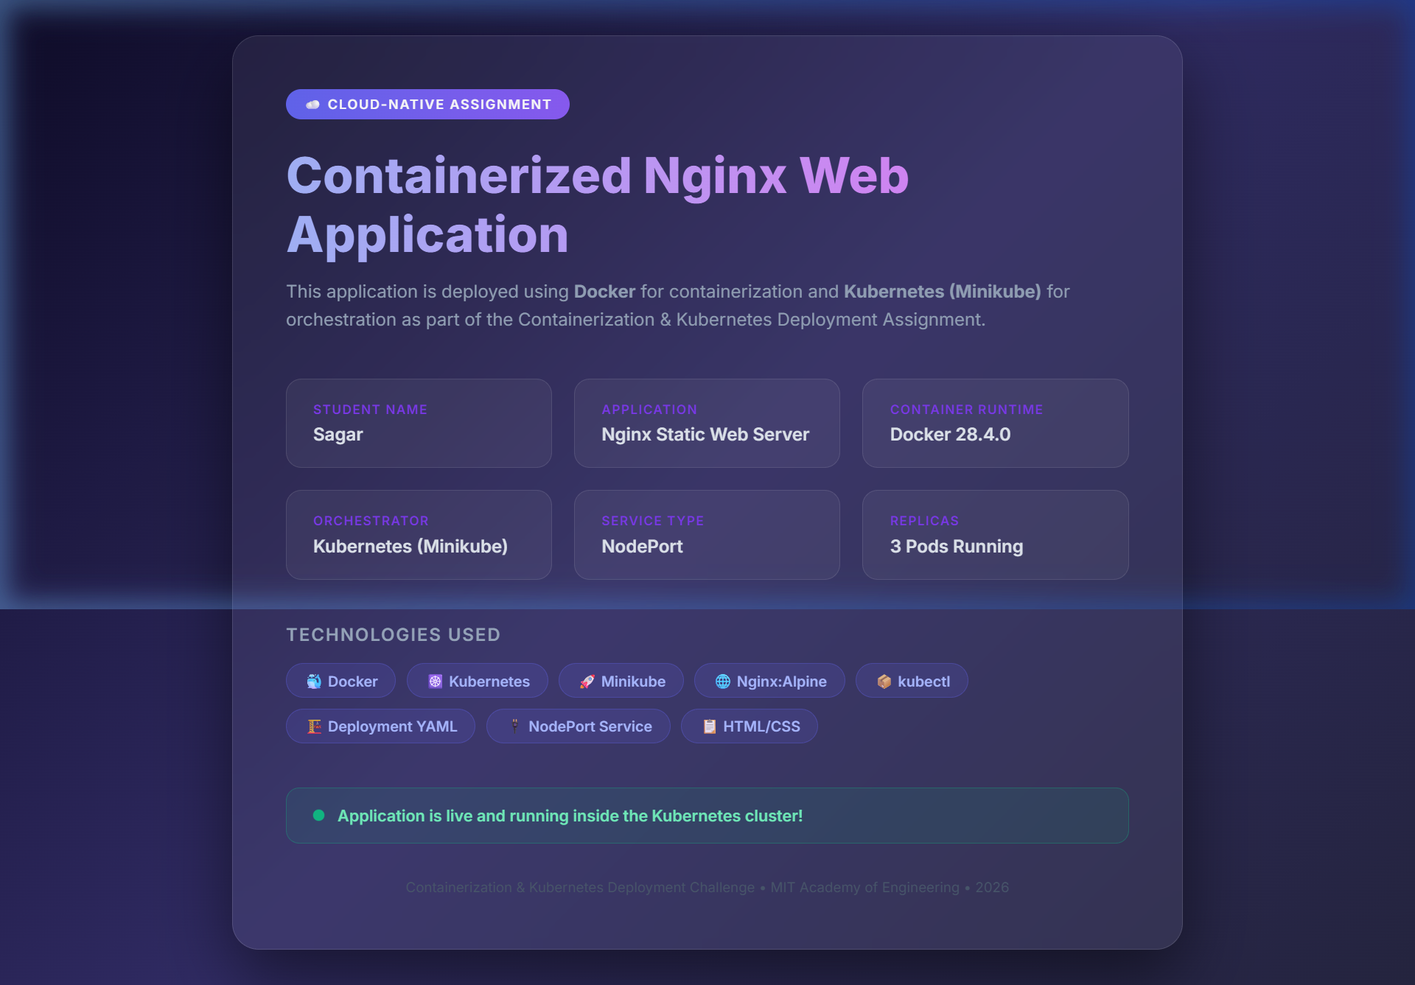
Figure 1: Nginx application running inside the Kubernetes cluster (accessed via port-forward)

7. Cloud-Native Concepts Explained

- Containerization (Docker) — Packages the application and all its dependencies (Nginx, config, HTML) into a portable, self-contained image. Any machine with Docker can run this identical environment.
- Image Layering & Caching — Each Dockerfile instruction creates a layer. Unchanged layers are cached, making rebuilds fast. Our image reuses the nginx:alpine base across builds.
- Kubernetes Deployment — A Deployment controller ensures the desired number of pod replicas are always running. If a pod crashes, Kubernetes automatically restarts it.
- ReplicaSet — Automatically created by the Deployment. Maintains 3 identical pod replicas distributed across available nodes for high availability.
- NodePort Service — Exposes the application on a static port (30080) on every cluster node IP, enabling external access outside the cluster.
- Liveness & Readiness Probes — Liveness probes restart unhealthy containers. Readiness probes prevent traffic from reaching pods that are not yet ready to serve requests.
- Resource Requests & Limits — Requests guarantee minimum CPU/memory for scheduling. Limits cap maximum usage, preventing any pod from starving other pods on the node.
- Rolling Update Strategy — maxUnavailable=0 ensures zero-downtime deployments — new pods start before old ones stop, keeping the service continuously available during updates.

8. Steps to Reproduce (Run & Verify)

Step 1 — Verify Prerequisites
docker --version
kubectl version --client
minikube version
Step 2 — Start Minikube
minikube start --driver=docker
Step 3 — Configure Docker to use Minikube daemon
& minikube -p minikube docker-env --shell powershell | Invoke-Expression
Step 4 — Build Docker Image
docker build -t nginx-assignment:1.0 .
docker images nginx-assignment
Step 5 — Deploy to Kubernetes
kubectl apply -f k8s/deployment.yaml
kubectl apply -f k8s/service.yaml
Step 6 — Wait for rollout
kubectl rollout status deployment/nginx-assignment-deployment --timeout=90s
Step 7 — Verify pods & service
kubectl get pods -l app=nginx-assignment -o wide
kubectl get service nginx-assignment-service
kubectl get all -l app=nginx-assignment
Step 8 — Access the application
# Option A: Via Minikube service URL (opens browser)
minikube service nginx-assignment-service
# Option B: Via port-forward
kubectl port-forward service/nginx-assignment-service 8080:80
# Visit: http://localhost:8080
Step 9 — Check logs
kubectl logs -l app=nginx-assignment --tail=10
Step 10 — Cleanup
kubectl delete -f k8s/deployment.yaml
kubectl delete -f k8s/service.yaml
minikube stop

9. Grading Criteria Self-Assessment

Rubric Criterion | Max Marks | What Was Done
Dockerfile & Image Creation | 3 | Optimized Dockerfile with labels, HEALTHCHECK, nginx:alpine base; image builds without errors (sha256: a6881a4bcd64, 48.3 MB)
Container Execution | 3 | Application runs inside container; HTTP 200 confirmed; Kubernetes probes (kube-probe/1.34) hitting all 3 pods every 10–15s
Kubernetes Deployment | 4 | 3-replica Deployment with RollingUpdate (maxUnavailable=0), resource limits/requests, liveness+readiness probes; all 3/3 pods Running
Kubernetes Service | 2 | NodePort Service on port 30080; Cluster-IP 10.111.2.76; application accessible via minikube service & port-forward
Demonstration & Evidence | 3 | Full terminal output, describe output, pod logs with HTTP 200, live browser screenshot of running app included

✅ Total Expected: 15 / 15 marks

